Pedestrian Crossing

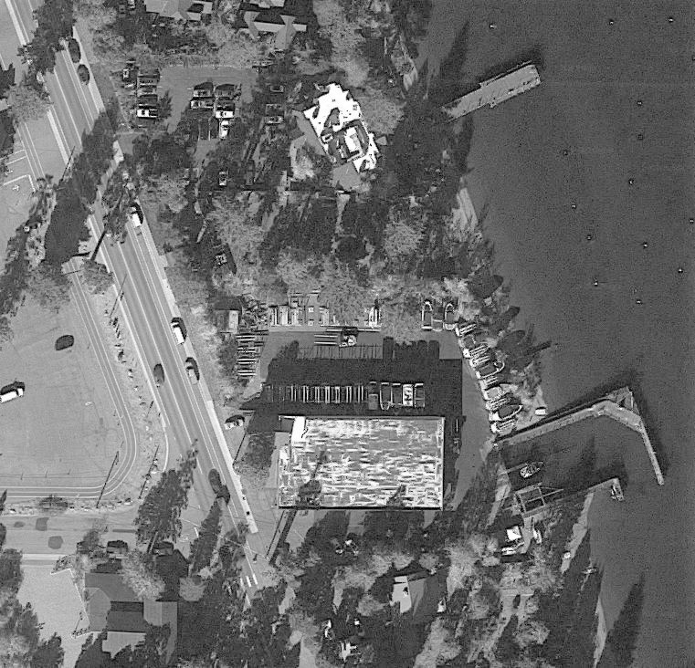

**MARINA**

**WSC**

Please cross safely at the crosswalks to avoid incidents.

Look both ways before crossing!

Always drive the speed limit and be aware of pedestrians as you drive by.

Be aware of increased pedestrian travel around TART bus stops and during events.

Give cyclists space.

Bears, deer, coyotes, and other animals may also cross the road so look out for our furry pedestrians too.