INVASIVE SPECIES

Aquatic invasive species are a growing threat to waterways throughout the nation and the west. These aquatic invaders include over 16 plant and animal species such as Eurasian watermilfoil, curlyleaf pondweed, zebra and quagga mussels, and Asian clams. Consequences of establishment include degradation of water quality, loss of important habitat for native species, impacts to water conveyance systems, boats, piers and other structures, and negative economic impacts to the Lake Tahoe Region. Aquatic invasive species are known to be transported from infested lakes and rivers via a variety of pathways, including trailered boats, fishing gear, waders, construction machinery, kayaks, and other watercraft.  They pose a serious threat to the Tahoe Basin’s unique natural environment and economy.

A good basic rule of thumb is if the boat is Clean Drained and Dry (CDD) then the vessel will have a low risk of spreading invasive species. Although quagga and zebra mussels have been known to live for weeks on dry boats.

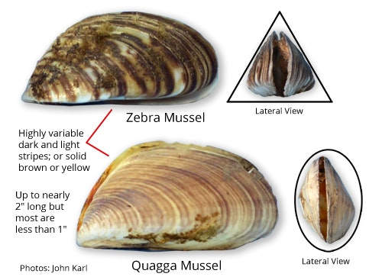Quagga and Zebra Mussels are the most crucial species to prevent from entering Lake Tahoe. If quagga mussels appear in Lake Tahoe, then the water will change from blue to clear to green, our beaches will be scattered with sharp mussel shells and our water pipes will soon clog with shells. Lake Havasu spends millions just clearing the water pipes of Arizona due to these creatures, resulting in an increase in water costs and taxes to combat the infestation.

While launching boats keep a look out for these “aquatic hitchhikers” and help protect Lake Tahoe!

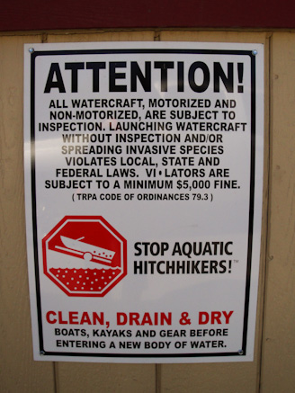***I*f you see anything hanging off a boat, trailer or outdrive, take a moment, and pull it off. If you happen to find quagga or zebra mussels on a vessel you must call (775) 588-4547 so that they may be properly removed and decontaminated.**

There is a $5,000 fine just for knowingly carrying quagga’s on your vessel so if a customer is giving you a hard time you can inform them of this.

**The starting fine for trying to launch a boat while knowingly carrying invasive species is around $250,000

Other Invasive Species to look out for:

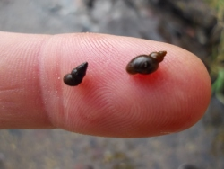

New Zealand Mud Snail: upsets entire water systems lower level food chains. Fish do not eat them.

These are already causing problems in the lower Truckee River and Reno Waterways

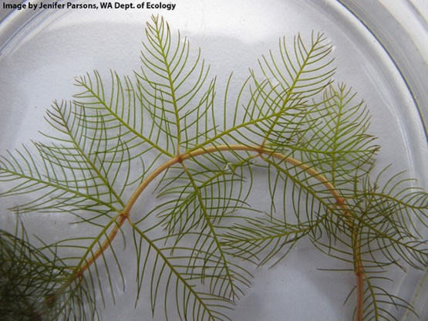

Eurasian Milfoil Weed: upsets plant eating fish and native plant environments. Also ruins boat props.

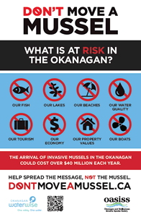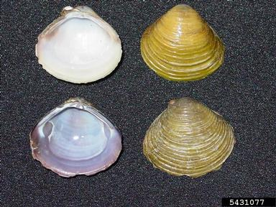

**LAKE TAHOE?**

Asian Clam:

Already been introduced to Tahoe in some areas of the lake. Removing them from boats prior to launch will help contain the population and prevent further spread.