Forklift Safety and Heavy Machinery

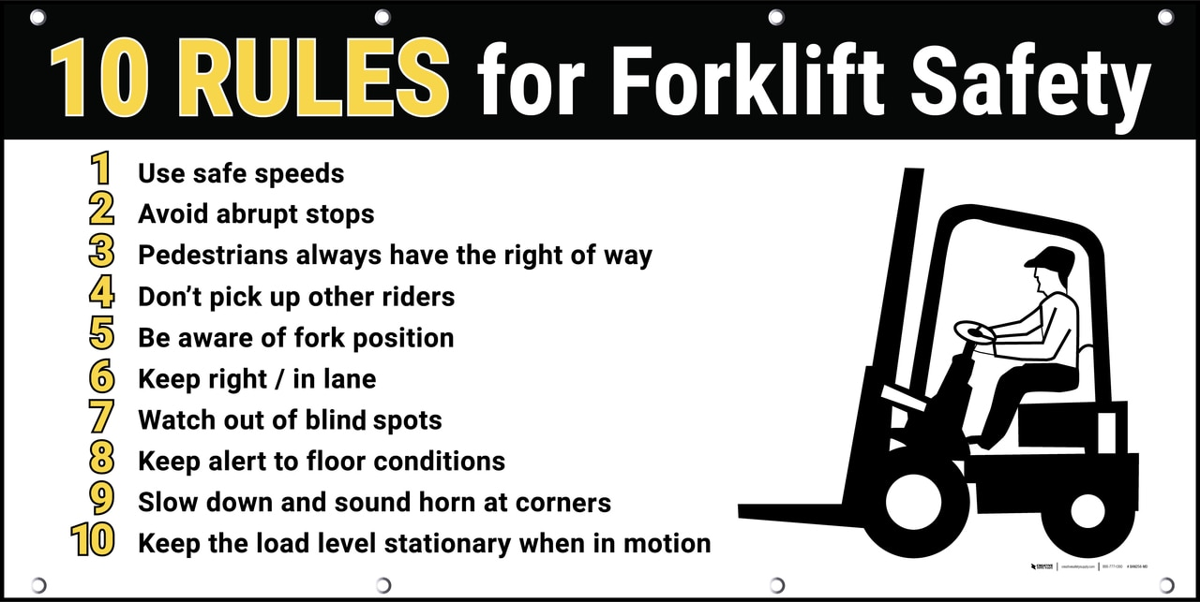

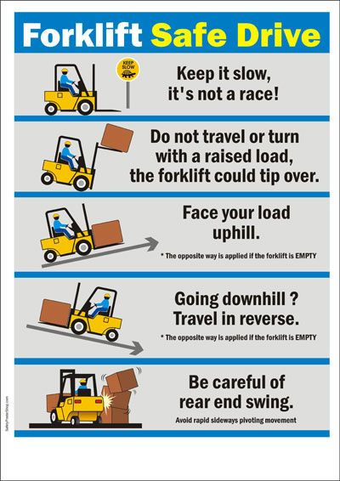

**Working Around Heavy Equipment**

Heavy equipment includes: folklifts, snow cats, bucket loaders, bobcats, helicopters, large trucks, snowplows, and more. All heavy equipment has blind spots and hazardous areas. Here are some tips that can help you to avoid injury:

* • If you need to speak to the operator - approach from a 45⁰ angle from the driver’s side (if possible) – any other angle is more dangerous
* • Make eye contact with the operator before approaching – never assume the operator can see you
* • Operators should neutralize the equipment before you approach, i.e., lower the bucket/blade, set the brake, reduce engine speed to idle
* • If you need to pass through the work area of a heavy machine wait until the operator sees you and waves you through. Never pass in front or behind a heavy machine without the operators permission.
* • Do not park behind or close to a heavy machine
* • Never go under a winch cable, or any suspended load
* • Do not rely on back-up alarms – give machines a wide berth
* • Never turn your back to an active machine – always pay attention and keep your distance
* • When in doubt – stay away
* • If you see someone breaking the rules, explain these points to them