

**Avoidance:** The best way to prevent unpleasant encounters with social wasps, such as yellow jackets, is to avoid them. If there is a chronic problem with yellow jackets around playgrounds, picnic areas, or athletic fields, inspect the area to locate the nests. Once you know where they are, have children avoid their nesting places. Avoid swatting and squashing yellow jackets because it is counterproductive. When a yellow jacket is squashed, a chemical (pheromone) is released that attracts and incites nearby yellow jackets. Avoid wearing bright colors, especially yellow, or floral patterns that may attract some foraging yellow jackets. Lastly, minimize the use of products with perfumes such as sweet-smelling shampoos, lotions or soaps, as yellow jackets are attracted to sweet smells.

**Stings and Symptoms:**Yellow jacket stings pose a more serious threat to people than stings of bees. Because a yellow jacket’s stinger is not barbed like a honeybee stinger, it can repeatedly sting its victim, whereas a bee can only sting once. It can be very frightening to be the victim of multiple yellow jacket stings. The first impulse may be to run away, however the best strategy is to back slowly away from the colony until they stop attacking. Some people are more sensitive than others to stings due to allergic reactions. People who experience large numbers of stings at once, may suffer severe reactions to the inflammatory substances in the insect’s venom.

Yellow jackets that are foraging for food will usually not sting unless physically threatened, such as being struck or swatted. Multiple stings from yellow jackets are common because they are sensitive to disturbance and aggressive in defense of their nests. Sometimes merely coming near a nest, especially if it has been disturbed previously, can provoke an attack. Problems with yellow jackets are most common in the fall.

**Reduce Their Food Sources:** In early fall, a yellow jacket’s food preference turns to sweets such as sugary drinks, ice cream, and fruit. Their behavior also turns more aggressive, and they are more willing to sting. Since garbage is a prime foraging and hunting site for yellow jackets, garbage containers should have tight fitting lids and be regularly cleaned of food waste. Otherwise, the garbage (and the flies around it) becomes a food source for yellow jackets.

[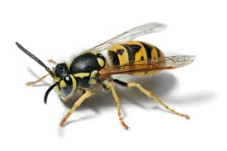](https://s3-us-gov-west-1.amazonaws.com/cg-c877c3f0-e413-40cd-a59c-ad2d6b211d1b/uploads/2016/09/yellowjacket.jpg)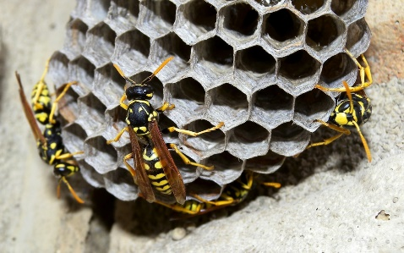Repair windows screens and caulk holes in siding to prevent yellow jackets and other flying insects from entering the building. Playground and building inspections for pests should be conducted monthly to ensure that developing nests are found and removed before they become problematic.

Bear Awareness

Black Bear Facts:

-The only species of bear in California and Nevada are Black Bears. However, they do range in color from blonde to black, with cinnamon brown being the most common color.

-There are an estimated 25,000 to 35,000 black bears in California and 200-300 in Nevada.

-Black Bears will seek to avoid with Humans. If encountered, always leave them an escape route. Do not scare the bear, let them aware of your presence without spooking them.

-Black Bears can sprint up to 35 mph and are strong swimmers and tree climbers.

-Black Bears are omnivores, a typical wild bear diet consists of berries, plants, nuts, roots, honey, honeycomb, insects, carrion, fish, and small animals.

-As winter approaches, bears will forage for food up to 20 hours a day, storing enough fat to sustain them through hibernation. Bears often hibernated in hollow trees 40 to 50 feet off the ground.

-Bears that are accustomed to people can become bold and lose their fear of humans. To avoid this behavior, do not let bears become habituated to human sources of food.

-A fed bear is a dead bear.

**There are simple steps that you can follow to protect local bears and other wildlife from a potentially deadly encounter. Remember, we must all act responsible in bear country to keep the bears Alive and Wild.**

**In Town:** Keep in mind that bears and other animals are attracted to anything edible or smelly.

Take precautions by using the following guidelines:

-Utilize public trash receptacles and dumpsters while visiting local parks and recreational facilities. Pay special attention when securing receptacles or dumpster lids.

-Keep bear-proof trash receptacle and dumpster lids closed, latched and locked at all times.

-Do not leave trash, groceries, or pet food in your car. If you absolutely must leave edible or smelly items in your car, then make sure the items are in an airtight container and locked in your trunk.

-Stow all edible or smelly products, including food, suntan lotion, insect repellent, soaps, deodorant, toothpaste/gum, candles, Chapstick, and flavored medicines properly. Keep these products inside your home or secured in bear lockers while camping.

**At Home:**

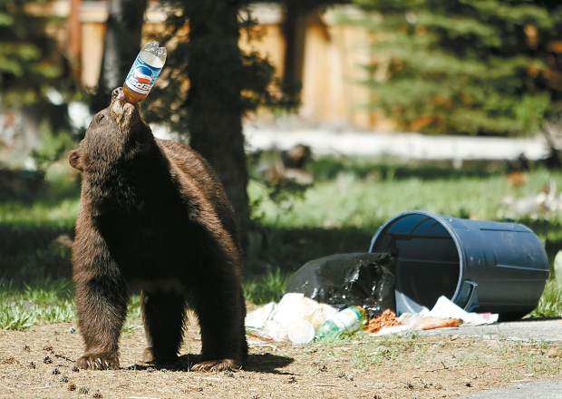 -Do not run. Assert your dominance by standing tall and making loud noises to scare the bear away. DO NOT SNEAK UP ON THE BEAR AND SCARE THEM. LET THEM KNOW YOU’RE THERE BEFORE MAKING LOUD NOISES.