**Air Quality / Protection From Wildfire Smoke**

In order to limit employees exposure to harmful conditions, Homewood Mountain Resort has created and will implement this plan in compliance with T8 CCR, [Section 5141](https://www.dir.ca.gov/title8/5141.html#:~:text=%C2%A75141.&text=Harmful%20exposures%20shall%20be%20prevented%20by%20engineering%20controls%20whenever%20feasible.&text=Whenever%20engineering%20controls%20are%20not,shall%20be%20implemented%20if%20practicable.), *Control of Harmful Exposure to Employees*, and Cal/OSHA emergency regulation [Section 5141.1](https://www.dir.ca.gov/title8/5141_1.html), *Protection from Wildfire Smoke*.

Emergency regulation 5141.1 effective dates have been extended and the regulation is expected to be made permanent. It applies to workplaces and operations where the current Air Quality Index (AQI) for PM2.5 particulate is 151 or greater ("unhealthy") and where the employer should reasonably anticipate that employees may be exposed to wildfire smoke. It requires the following which is included in these protocols:

1. **Identification of Harmful Exposures**– For worksites covered by the emergency regulation, employers must determine employee exposure to PM2.5 before each shift and periodically thereafter, as needed.
2. **Communication**– Employers must implement a system for communicating wildfire smoke hazards in a form readily understandable by all affected employees, including provisions designed to encourage employees to inform the employer of wildfire smoke hazards at the worksite without fear of reprisal.
3. **Training and instruction information (Appendix B)** – For worksites covered by the emergency regulation, employers must provide effective training that includes at least the information contained in Appendix B.
4. **Control of harmful exposures to employees**– Employers must reduce workers' exposure to wildfire smoke in the following ways:
   * If feasible, by providing an enclosed location with filtered air so that employee exposure to PM2.5 is less than a current AQI of 151.
   * If that is not feasible or adequate, by relocating to another outdoor location where the current AQI for PM2.5 is lower, changing work schedules, reducing work intensity, or providing more rest periods.
   * With respiratory protective equipment if employers cannot reduce workers' exposure to PM2.5 to a current AQI of 150 or lower.
     + Where the current AQI for PM2.5 is from 151 to 500, employers must provide NIOSH-approved particulate respirators, such as N95, N-99, N-100, R-95, P-95, P-99, or P-100 masks, to all employees for voluntary use, and training on the new regulation, the health effects of wildfire smoke, and the safe use and maintenance of respirators.
     + Where the current AQI for PM2.5 is higher than 500, the employer must provide and require employees to use NIOSH-approved particulate respirators that will reduce employee exposure to PM2.5 to an equivalent of an AQI less than 151.

# Identification of Harmful Exposures

Smoke from wildfires contains chemicals, gases and fine particles that can harm health. The greatest hazard comes from breathing fine particles in the air, which can reduce lung function, worsen asthma and other existing heart and lung conditions, and cause coughing, wheezing and difficulty breathing. Hazards continue even after fires have been extinguished and cleanup work begins. Proper protective equipment and training is required for worker safety in wildfire regions.

The smallest and usually the most harmful particulate matter is called PM2.5 (solid particles and liquid droplets suspended in air with an aerodynamic diameter of 2.5 micrometers or smaller). This is because it can get deep into the lungs when inhaled.

Measuring PM2.5 is the standard to indicate air quality and exposure to unhealthy conditions from wildfire smoke. This measurement is called the Air Quality Index, or AQI.

AQI, is EPA’s tool for communicating daily air quality. It uses color-coded categories and provides statements for each category that tell you about air quality in your area, which groups of people may be affected, and steps you can take to reduce your exposure to air pollution. It’s also used as the basis for air quality forecasts and current air quality reporting.

There’s a U.S. AQI for five major pollutants that are regulated by the Clean Air Act: ozone, particle pollution (also called particulate matter), carbon monoxide, nitrogen dioxide and sulfur dioxide. **Make sure that AQI measurements used for wildfire smoke monitoring are measuring PM2.5.**

AQI should be monitored hourly throughout the day if smokey conditions are present. In order to make sure that we are monitoring PM2.5, and not other pollutants, we will use the EPA’s AirNow website as approved by Cal/OSHA 5141.1. There is a subset of the website committed to wildfire smoke hazards which is available here:

<https://fire.airnow.gov/>

Simply allow the website to determine your location or zoom in to find your inspection station. Select the dots (representing monitoring equipment) nearest to your location to get the readings for PM2.5 near you. Circular dots represent permanent monitoring equipment and is preferred if available in your area.

The higher the AQI value, the greater the level of air pollution and the greater the health concern. For example, an AQI value of 50 or below represents good air quality, while an AQI value over 300 represents hazardous air quality.

For each pollutant, an AQI value of 100 generally corresponds to an ambient air concentration that equals the level of the short-term national ambient air quality standard for protection of public health. AQI values at or below 100 are generally thought of as satisfactory. When AQI values are above 100, air quality is unhealthy: at first for certain sensitive groups of people, then for everyone as AQI values get higher.

The AQI is divided into six categories. Each category corresponds to a different level of health concern. Each category also has a specific color. The color makes it easy for people to quickly determine whether air quality is reaching unhealthy levels in their communities.

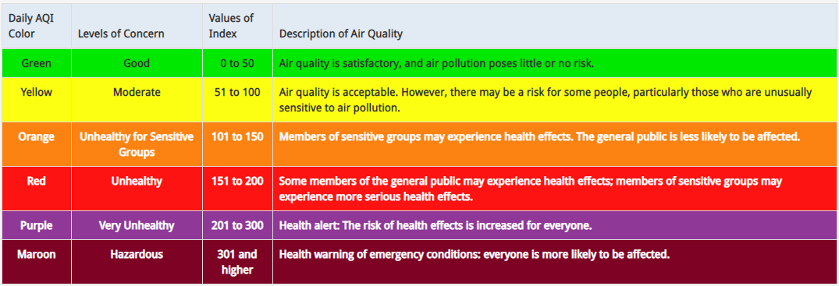

On smokey days, acting Supervisors should keep a log of the AQI at each site on an hourly basis. This should include notes on the real-life impacts felt by employees, such as:

9:ooAM, AQI:251, limited visibility, mild eye irritation

# Communication

Acting Supervisors will research and inform employees at their station of the first few required communications including:

1. The current AQI for PM2.5 as outlined in 5141.1 subsection (c)
2. The available protective measures (outlined below) available to employees to reduce their wildfire smoke exposures

Acting Supervisors must also communicate with management whenever the AQI has elevated to a point that requires additional mitigation. The primary point of contact is your Manager or Director.

1. Supervisors must communicate worsening air quality and…
2. Any adverse symptoms that may be the result of wildfire smoke exposure such as asthma attacks, difficulty breathing, and chest pain.

Guidance and requirements provided by Cal OSHA suggest that readings above 151 are potentially harmful to employees. Above an AQI of 500, Cal OSHA requires employees to wear appropriate masks.

**DECISION MATRIX- The WIP has set the following actions to be implemented immediately upon worsening air quality conditions:**

**AQI 151-200 (Unhealthy)**

Employees are provided appropriate masks for voluntary use and should limit exertion when exposed. All employees should make an effort to limit time outside and to maintain an indoor air quality that is improved over that of the outside air by shutting windows and doors. Entry into this index category also suggests that employees take additional rest periods as needed. The Program suggests an additional 5 minutes per half hour. Employees are encouraged to drink plenty of water when this condition exists.

**AQI 201-300 (Very Unhealthy)**

Employees are highly encouraged to use the provided masks while at work. Ten minute rest periods per hour are mandatory for all employees. No heavy exertion should be performed, and employees should maximize their time indoors or in vehicles. Additional workloads (such as inspections from the waitlist or double appointments) may be abandoned for the day and rescheduled if staffing is not adequate to allow for compliance with the prior requirements for safety.

**AQI >301 (Hazardous)**

All new work will be postponed immediately. Employees have the option to complete the current inspections or decontaminations. Employees will retreat to an indoor location with windows and doors closed for a period of 1 hour, after which the AQI will be checked again. If the AQI remains above 301, staff will wait an additional hour on site. Should conditions improve, employees will resume work following the directions listed under the appropriate AQI above. If conditions do not improve or worsen, employees will close the site for the day and reschedule missed appointments. In this case, employees will be compensated for the entire work day.

**AQI >400**

If at any point AQI reaches a level greater than 400, all employees are to immediately cease all work and will close the entire site for the day.

In addition to AQI readings, if at any point an employee shows signs of injury or illness due to wildfire smoke exposure, they should seek medical treatment, and will not be punished for seeking such treatment. Employees should seek prompt medical treatment in the event of serious injury or illness caused by wildfire smoke exposure by following the Exposure Control Plan available at every site. Those in need of medical attention should first try the nearest Urgent Care facility unless the Emergency Room is determined to be the most appropriate. Homewood Mountain Resort’s human resources department can help locate these facilities if needed. Contact information is available below:

Meg Peart

530-543-1501 x 100

# Training and Instruction

Homewood Mountain Resort will train employees on these protocols and provide 5141.1 Appendix B in full (below) so that employees are aware of Cal/OSHA requirements of the employer for the protection of employees from wildfire smoke.

# Control of Harmful Exposures to Employees

1. Engineering Controls

Offices at each site are provided and are a suitable place to seek shelter from smokey weather, although employees should be aware that offices are not guaranteed to provide enough filtration to limit AQI values to <151. Employees are encouraged to maximize time inside with the windows and doors closed. Masks are encouraged while inside the building.

1. Administrative Controls

Employees are encouraged to take breaks and drink water frequently as needed or as outlined above under *2) Communication* when smokey conditions exist. In addition, at certain AQI levels, acting Supervisors will have the option to limit workload and ultimately, close operations should AQI levels escalate.

1. Control by respiratory Protective Equipment

Where the current AQI for PM2.5 is equal to or greater than 151, but does not exceed 500, n95 particle filter respirators are provided for the use of all employees for voluntary use in accordance with section 5144. Employees are encouraged to use them.

Respirators shall be NIOSH-approved devices that effectively protect the wearers from inhalation of PM2.5, such as N95 filtering facepiece respirators or others listed above. Respirators shall be cleaned, stored, maintained, and replaced so that they do not present a health hazard to users. Employees will be trained using Appendix B (below) regarding voluntary use of respirators.

Where the current AQI for PM2.5 exceeds 500, respirator use is required in accordance with section 5144. In accordance with these protocols, and for the safety of all employees, all operations will have ceased prior to this requirement.

NOTE: For voluntary use of filtering facepieces, such as N95 respirators, which is the case for the duration of all operations under the Watercraft Inspection Program, some of the requirements of section 5144 do not apply, such as fit testing and medical evaluations.

Note: Authority cited: Section 142.3, Labor Code. Reference: Sections 142.3 and 144.6, Labor Code.

# [Appendix B - Protection from Wildfire Smoke Information to Be Provided to Employees (Mandatory)](https://www.dir.ca.gov/Title8/5141_1b.html)

(a) The health effects of wildfire smoke.

Although there are many hazardous chemicals in wildfire smoke, the main harmful pollutant for people who are not very close to the fire is “particulate matter,” the tiny particles suspended in the air.

Particulate matter can irritate the lungs and cause persistent coughing, phlegm, wheezing, or difficulty breathing. Particulate matter can also cause more serious problems, such as reduced lung function, bronchitis, worsening of asthma, heart failure, and early death.

People over 65 and people who already have heart and lung problems are the most likely to suffer from serious health effects.

The smallest -and usually the most harmful -particulate matter is called PM2.5 because it has a diameter of 2.5 micrometers or smaller.

(b) The right to obtain medical treatment without fear of reprisal.

Employers shall allow employees who show signs of injury or illness due to wildfire smoke exposure to seek medical treatment, and may not punish affected employees for seeking such treatment. Employers shall also have effective provisions made in advance for prompt medical treatment of employees in the event of serious injury or illness caused by wildfire smoke exposure.

(c) How employees can obtain the current Air Quality Index (AQI) for PM2.5.

Various government agencies monitor the air at locations throughout California and report the current AQI for those places. The AQI is a measurement of how polluted the air is. An AQI over 100 is unhealthy for sensitive people and an AQI over 150 is unhealthy for everyone.

Although there are AQIs for several pollutants, Title 8, section 5141.1 about wildfire smoke only uses the AQI for PM2.5.

The easiest way to find the current and forecasted AQI for PM2.5 is to go to www.AirNow.gov and enter the zip code of the location where you will be working. The current AQI is also available from the U.S. Forest Service at https://tools.airfire.org/ or a local air district, which can be located at www.arb.ca.gov/capcoa/dismap.htm. Employees who do not have access to the internet can contact their employer for the current AQI. The EPA website www.enviroflash.info can transmit daily and forecasted AQIs by text or email for particular cities or zip codes.

(d) The requirements in Title 8, section 5141.1 about wildfire smoke.

If employees may be exposed to wildfire smoke, then the employer is required to find out the current AQI applicable to the worksite. If the current AQI for PM2.5 is 151 or more, the employer is required to:

(1) Check the current AQI before and periodically during each shift.

(2) Provide training to employees.

(3) Lower employee exposures.

(4) Provide respirators and encourage their use.

(e) The employer's two-way communication system.

Employers shall alert employees when the air quality is harmful and what protective measures are available to employees.

Employers shall encourage employees to inform their employers if they notice the air quality is getting worse, or if they are suffering from any symptoms due to the air quality, without fear of reprisal.

The employer's communication system is: See above Protocols __________

_______________________________________________________________

_______________________________________________________________

(f) The employer's methods to protect employees from wildfire smoke.

Employers shall take action to protect employees from PM2.5 when the current AQI for PM2.5 is 151 or greater. Examples of protective methods include:

(1) Locating work in enclosed structures or vehicles where the air is filtered.

(2) Changing procedures such as moving workers to a place with a lower current AQI for PM2.5.

(3) Reducing work time in areas with unfiltered air.

(4) Increasing rest time and frequency, and providing a rest area with filtered air.

(5) Reducing the physical intensity of the work to help lower the breathing and heart rates.

The employer's control system at this worksite is: See above Protocols __________

_______________________________________________________________

_______________________________________________________________

(g) The importance, limitations, and benefits of using a respirator when exposed to wildfire smoke.

Respirators can be an effective way to protect employee health by reducing exposure to wildfire smoke, when they are properly selected and worn. Respirator use can be beneficial even when the AQI for PM2.5 is less than 151, to provide additional protection.

When the current AQI for PM2.5 is 151 or greater, employers shall provide their workers with proper respirators for voluntary use. If the current AQI is greater than 500, respirator use is required.

A respirator should be used properly and kept clean.

The following precautions shall be taken:

(1) Employers shall select respirators certified for protection against the specific air contaminants at the workplace. NIOSH, the National Institute for Occupational Safety and Health of the U.S. Center for Disease Control and Prevention certifies respirators. A label or statement of certification should appear on the respirator or respirator packaging. It will list what the respirator is designed for (particulates, for example).

Surgical masks or items worn over the nose and mouth such as scarves, T-shirts, and bandannas will not provide protection against wildfire smoke. An N95 filtering facepiece respirator, shown in the image below, is the minimum level of protection for wildfire smoke.

(2) Read and follow the manufacturer's instructions on the respirator's use, maintenance, cleaning and care, along with any warnings regarding the respirator's limitations. The manufacturer's instructions for medical evaluations, fit testing, and shaving should also be followed, although doing so is not required by Title 8, section 5141.1 for voluntary use of filtering facepiece respirators.

(3) Do not wear respirators in areas where the air contains contaminants for which the respirator is not designed. A respirator designed to filter particles will not protect employees against gases or vapors, and it will not supply oxygen.

(4) Employees should keep track of their respirator so that they do not mistakenly use someone else's respirator.

(5) Employees who have a heart or lung problem should ask their doctor before using a respirator.

(h) How to properly put on, use, and maintain the respirators provided by the employer.

To get the most protection from a respirator, there must be a tight seal around the face. A respirator will provide much less protection if facial hair interferes with the seal. Loose-fitting powered air purifying respirators may be worn by people with facial hair since they do not have seals that are affected by facial hair.

The proper way to put on a respirator depends on the type and model of the respirator.

For those who use an N95 or other filtering facepiece respirator mask that is made of filter material:

(1) Place the mask over the nose and under the chin, with one strap placed below the ears and one strap above.

(2) Pinch the metal part (if there is one) of the respirator over the top of the nose so it fits securely.

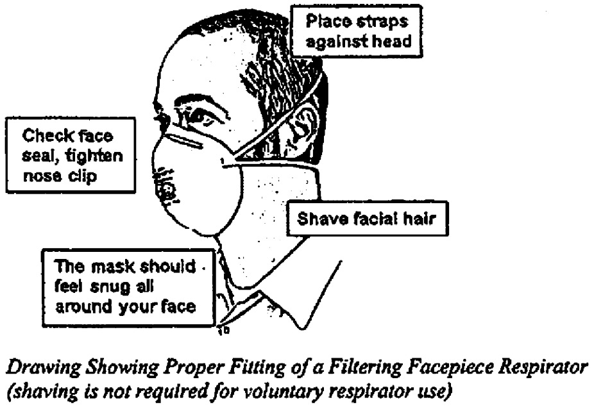

For a respirator that relies on a tight seal to the face, check how well it seals to the face by following the manufacturer's instructions for user seal checks. Adjust the respirator if air leaks between the seal and the face. The more air leaks under the seal, the less protection the user receives.

Respirator filters should be replaced if they get damaged, deformed, dirty, or difficult to breathe through. Filtering facepiece respirators are disposable respirators that cannot be cleaned or disinfected. A best practice is to replace filtering facepiece respirators at the beginning of each shift.

If you have symptoms such as difficulty breathing, dizziness, or nausea, go to an area with cleaner air, take off the respirator, and get medical help.

Note: Authority cited: Section 142.3, Labor Code. Reference: Sections 142.3 and 144.6, Labor Code.

**HISTORY**

1. New Appendix B filed 7-29-2019 as an emergency; operative 7-29-2019 (Register 2019, No. 31). A Certificate of Compliance must be transmitted to OAL by 1-27-2020 or emergency language will be repealed by operation of law on the following day.

2. New Appendix B refiled 1-16-2020 as an emergency; operative 1-24-2020 pursuant to Government Code section 11346.1(d) (Register 2020, No. 3). A Certificate of Compliance must be transmitted to OAL by 4-23-2020 or emergency language will be repealed by operation of law on the following day.

3. New Appendix B refiled 4-30-2020 as an emergency; operative 6-23-2020 pursuant to Government Code section 11346.1(d) (Register 2020, No. 18). A Certificate of Compliance must be transmitted to OAL by 9-21-2020 or emergency language will be repealed by operation of law on the following day.